ADVANCE FILE OPERATIONS

Race Condition
- Write a C program where two processes simultaneously write to the same file. Demonstrate the race condition and suggest a solution using file locks.

PROGRAM:

/*
Program to implement race condition
Author : MUTHUGANESH S
Date : 05/02/2026
Filename : race.c
*/

//Header files
#include <stdio.h>
#include <unistd.h>
#include <fcntl.h>
#include <stdlib.h>
#include <string.h>

//Functions to lock and unlock the file
void lock_file(int fd)
{
struct flock lock;
lock.l_type = F_WRLCK;
lock.l_whence = SEEK_SET;
lock.l_start = 0;
lock.l_len = 0;
fcntl(fd, F_SETLKW, &lock);
}

void unlock_file(int fd)
{
struct flock lock;

lock.l_type = F_UNLCK;
lock.l_whence = SEEK_SET;
lock.l_start = 0;
lock.l_len = 0;

fcntl(fd, F_SETLK, &lock);
}

int main()
{
int fd;
pid_t pid;
char buffer[100];

fd = open("race.txt", O_WRONLY | O_CREAT | O_APPEND, 0644);

if(fd < 0)
{
perror("open");
exit(1);
}

pid = fork();

for(int i=0;i<5;i++)
{
lock_file(fd);

if(pid==0)
sprintf(buffer,"Child writing %d\n",i);
else
sprintf(buffer,"Parent writing %d\n",i);

write(fd,buffer,strlen(buffer));

unlock_file(fd);

sleep(1);
}

close(fd);
}

/*
Porgram to prevent file locking
Author : MUTHUGANESH S
Date : 05/02/2026
Filename : race.c
*/

#include <stdio.h>
#include <unistd.h>
#include <fcntl.h>
#include <stdlib.h>
#include <string.h>

//Functions to lock and unlock the file
void lock_file(int fd)
{
struct flock lock;

lock.l_type = F_WRLCK;
lock.l_whence = SEEK_SET;
lock.l_start = 0;
lock.l_len = 0;

fcntl(fd, F_SETLKW, &lock);
}

//Functions to lock and unlock the file
void unlock_file(int fd)
{
struct flock lock;

lock.l_type = F_UNLCK;
lock.l_whence = SEEK_SET;
lock.l_start = 0;
lock.l_len = 0;

fcntl(fd, F_SETLK, &lock);
}

int main()
{
int fd;
pid_t pid;
char buffer[50];

fd = open("race.txt", O_WRONLY | O_CREAT | O_APPEND, 0644);

if(fd < 0)
{
perror("open");
exit(1);
}

pid = fork();

for(int i = 0; i < 5; i++)
{
lock_file(fd);

if(pid == 0)
sprintf(buffer, "Child process writing %d\n", i);
else
sprintf(buffer, "Parent process writing %d\n", i);

write(fd, buffer, strlen(buffer));

unlock_file(fd);

usleep(100000);
}

close(fd);
return 0;
}

OUTPUT:

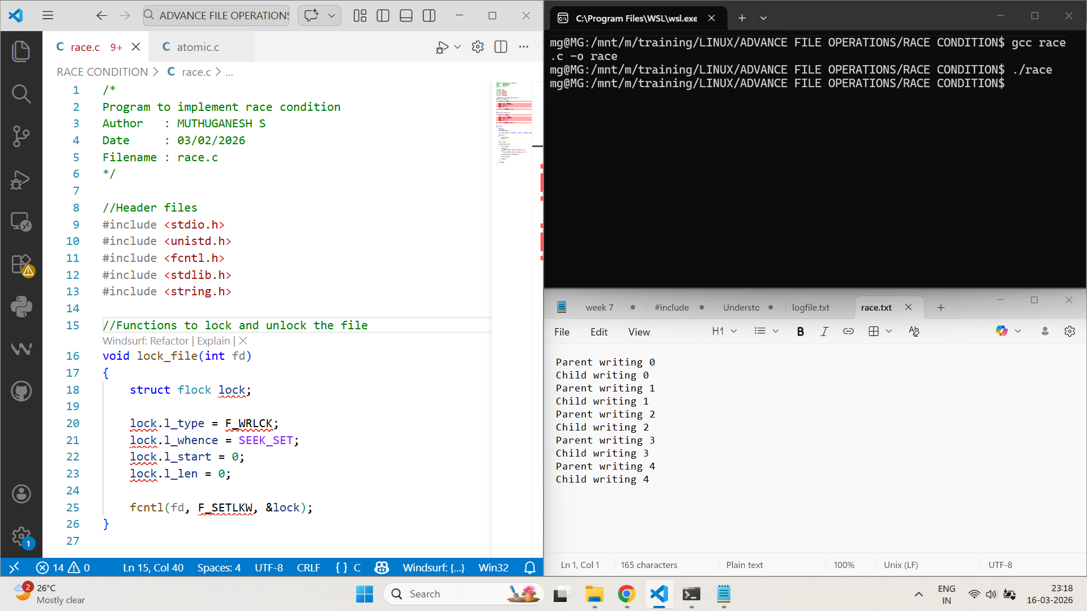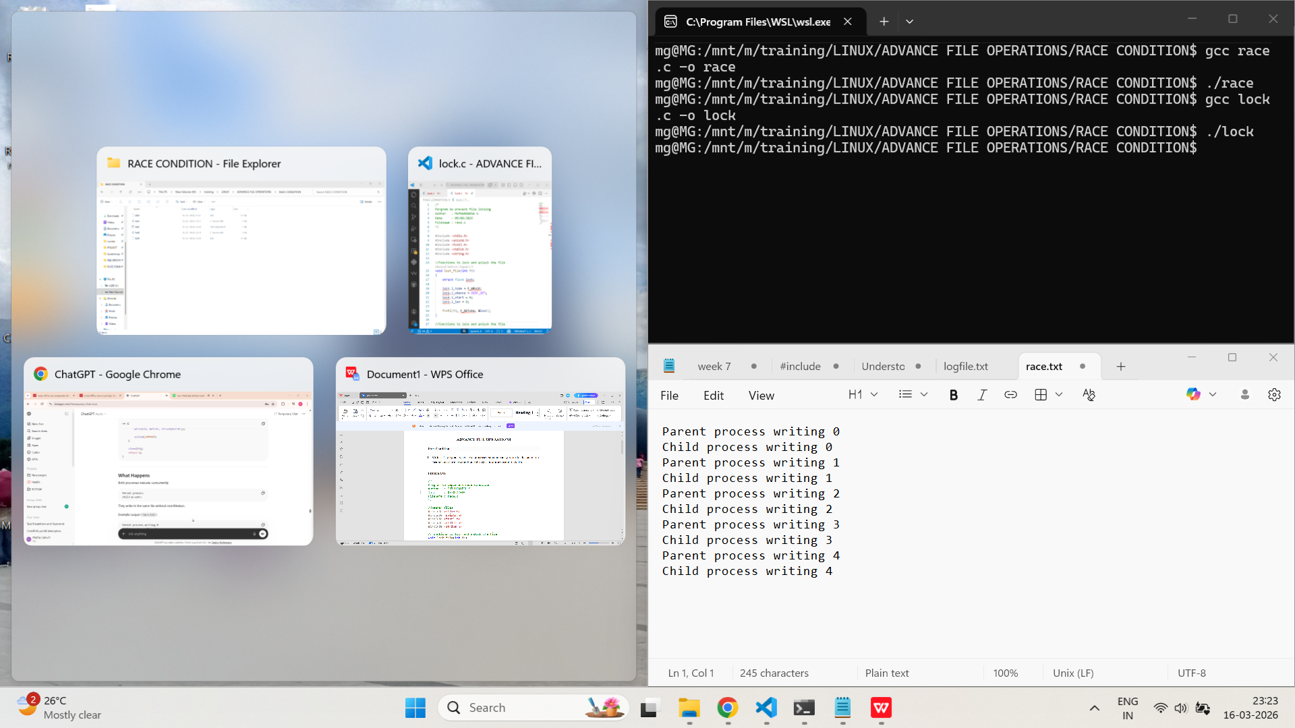

Atomicity
- Write a C program that appends data to a file from multiple processes. How do you ensure the append operation is atomic?
PROGRAM:
/*
Program to implement atomic log file
Author : MUTHUGANESH S
Date : 05/02/2026
Filename : atomic.c
*/

//Header files
#include <stdio.h>
#include <unistd.h>
#include <fcntl.h>
#include <stdlib.h>
#include <string.h>

int main()
{
int fd;
pid_t pid;
char buffer[100];

fd = open("atomic_log.txt", O_WRONLY | O_CREAT | O_APPEND, 0644);

if(fd < 0)
{
perror("open");
exit(1);
}

pid = fork();

for(int i = 0; i < 5; i++)
{
if(pid == 0)
sprintf(buffer, "Child process %d writing line %d\n", getpid(), i);
else
sprintf(buffer, "Parent process %d writing line %d\n", getpid(), i);

write(fd, buffer, strlen(buffer));

sleep(1);
}

close(fd);
return 0;
}
OUTPUT:
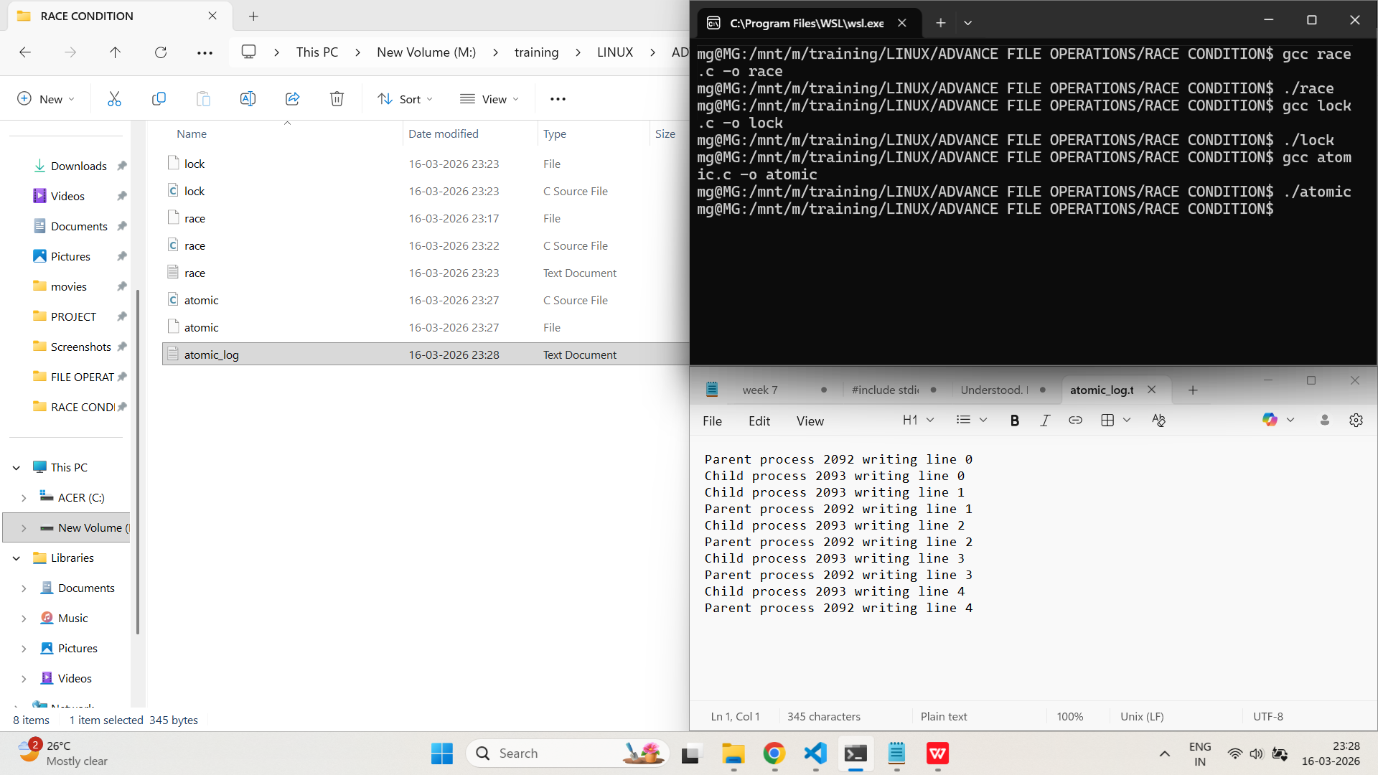
- Demonstrate atomic read-modify-write on a shared file using system calls. What happens if atomicity is not guaranteed?
PROGRAM:
/*
Program to read write modify in atomic mode
Author : MUTHUGANESH S
Date : 05/02/2026
Filename : rwm.c
*/

#include <stdio.h>
#include <unistd.h>
#include <fcntl.h>
#include <stdlib.h>

void lock_file(int fd)
{
struct flock lock;

lock.l_type = F_WRLCK;
lock.l_whence = SEEK_SET;
lock.l_start = 0;
lock.l_len = 0;

fcntl(fd, F_SETLKW, &lock);
}

void unlock_file(int fd)
{
struct flock lock;

lock.l_type = F_UNLCK;
lock.l_whence = SEEK_SET;
lock.l_start = 0;
lock.l_len = 0;

fcntl(fd, F_SETLK, &lock);
}

int main()
{
int fd;
int value;
pid_t pid;

fd = open("counter.txt", O_RDWR | O_CREAT, 0644);

if(fd < 0)
{
perror("open");
exit(1);
}

pid = fork();

for(int i = 0; i < 5; i++)
{
lock_file(fd);

lseek(fd, 0, SEEK_SET);
read(fd, &value, sizeof(int));

value++;

lseek(fd, 0, SEEK_SET);
write(fd, &value, sizeof(int));

printf("Process %d updated counter to %d\n", getpid(), value);

unlock_file(fd);

sleep(1);
}

close(fd);
return 0;
}
OUTPUT:
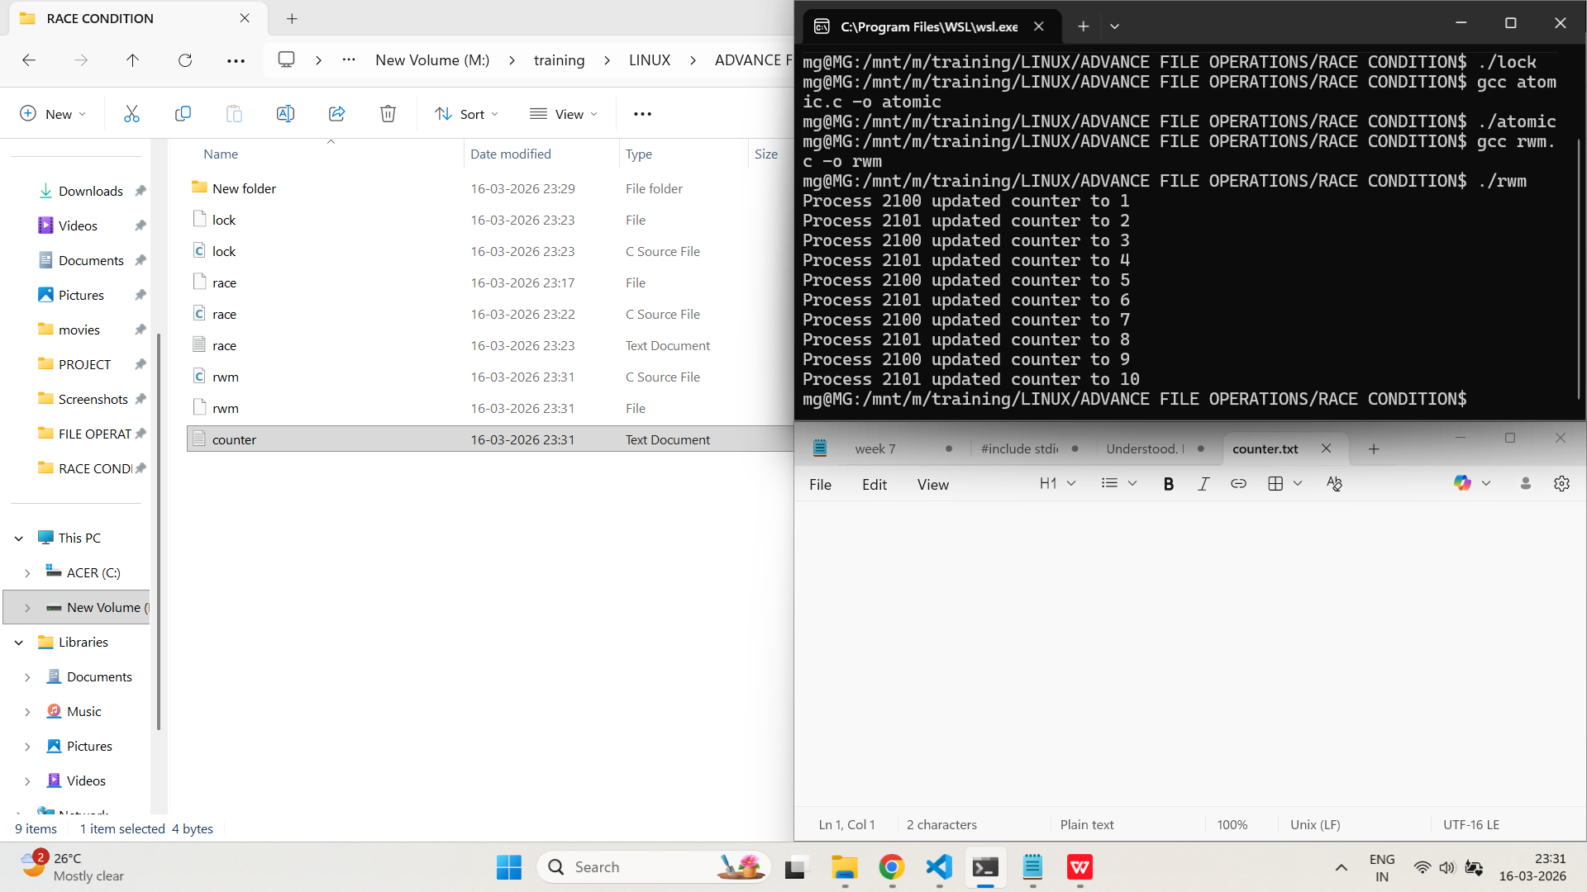
Pre-Emptive and Non Pre-Emptive Concept
- Write a C program using threads to show how pre-emptive scheduling can cause unexpected results when accessing shared data.
PROGRAM:
/*
Program to demonstrate the pre emption of threads
Author : MUTHUGANESH S
Date : 07/02/2026
Filename : pre.c
*/

#include <stdio.h>
#include <pthread.h>

int counter = 0;

//Function to increment the counter
void *increment(void *arg)
{
for(int i = 0; i < 1000000; i++)
{
counter++;
}
return NULL;
}

int main()
{
//Declare two threads
pthread_t t1, t2;

//Create two threads
pthread_create(&t1, NULL, increment, NULL);
pthread_create(&t2, NULL, increment, NULL);

//Join the threads
pthread_join(t1, NULL);
pthread_join(t2, NULL);

printf("Final Counter Value: %d\n", counter);

return 0;
}

OUTPUT:
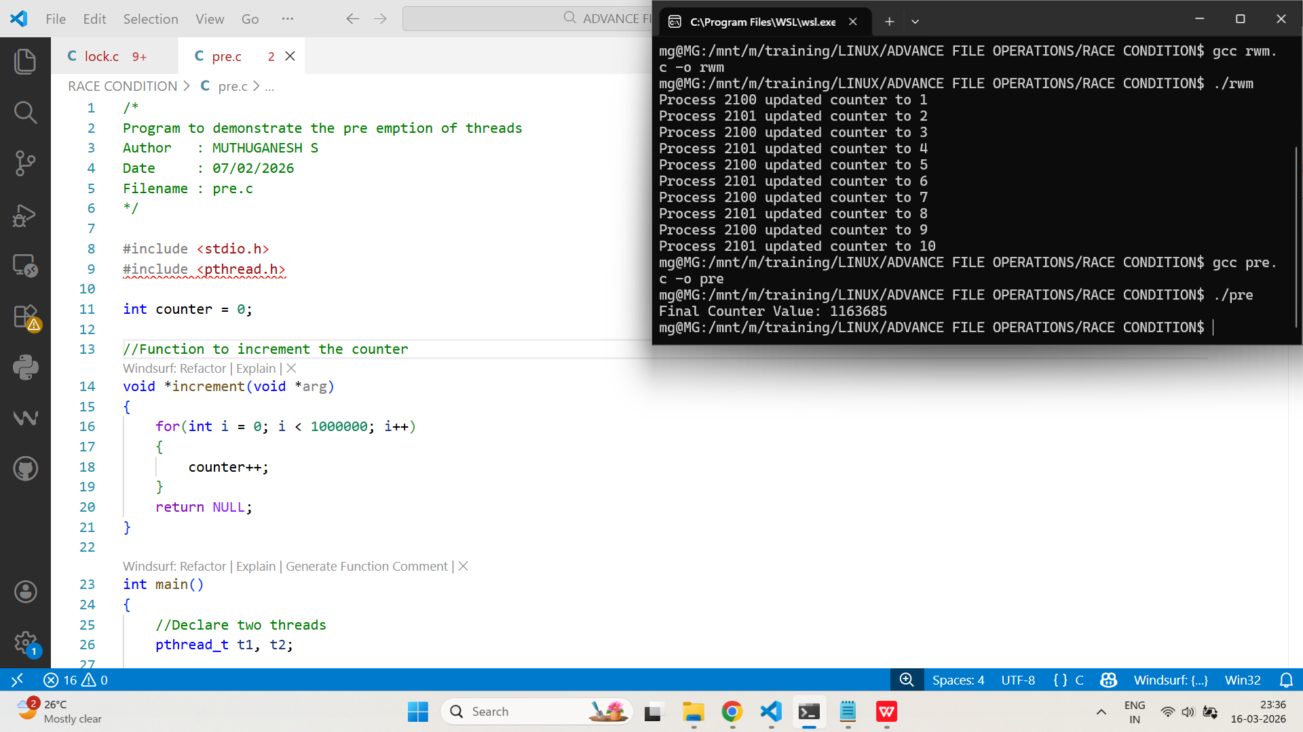
File Descriptor Table and Open File Table
- Write a C program to open multiple files and display their file descriptors. Explain the relationship between the process’s file descriptor table and the system-wide open file table.
PROGRAM:
/*
Program to create 3 files
Author : MUTHUGANESH S
Date : 05/02/2026
Filename : ThreeFiles.c
*/

#include <stdio.h>
#include <fcntl.h>
#include <unistd.h>

int main()
{
//Declaring file descriptors
int fd1, fd2, fd3;

//Creating 3 files
fd1 = open("file1.txt", O_CREAT | O_RDWR, 0644);
fd2 = open("file2.txt", O_CREAT | O_RDWR, 0644);
fd3 = open("file3.txt", O_CREAT | O_RDWR, 0644);

if(fd1 < 0 || fd2 < 0 || fd3 < 0)
{
perror("File open error");
return 1;
}

printf("File Descriptor for file1.txt : %d\n", fd1);
printf("File Descriptor for file2.txt : %d\n", fd2);
printf("File Descriptor for file3.txt : %d\n", fd3);

close(fd1);
close(fd2);
close(fd3);

return 0;
}

OUTPUT:
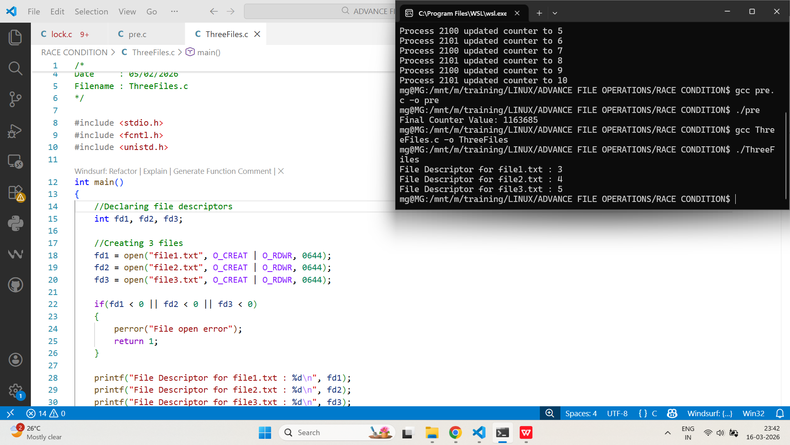
- Demonstrate how closing a file descriptor affects the file descriptor table and open file table. What happens if multiple descriptors refer to the same file?
PROGRAM:
/*
Program to create a file and duplicate the file descriptor
Author : MUTHUGANESH S
Date : 05/02/2026
Filename : dup.c
*/

#include <stdio.h>
#include <fcntl.h>
#include <unistd.h>

int main()
{
//Declaring file descriptors
int fd1, fd2;

//Creating a file
fd1 = open("test.txt", O_CREAT | O_RDWR, 0644);

//Duplicating the file
fd2 = dup(fd1);

//Print the file descriptors
printf("Original FD: %d\n", fd1);
printf("Duplicate FD: %d\n", fd2);

close(fd1);

printf("Closed fd1\n");

write(fd2, "Hello\n", 6);

close(fd2);

return 0;
}
OUTPUT:
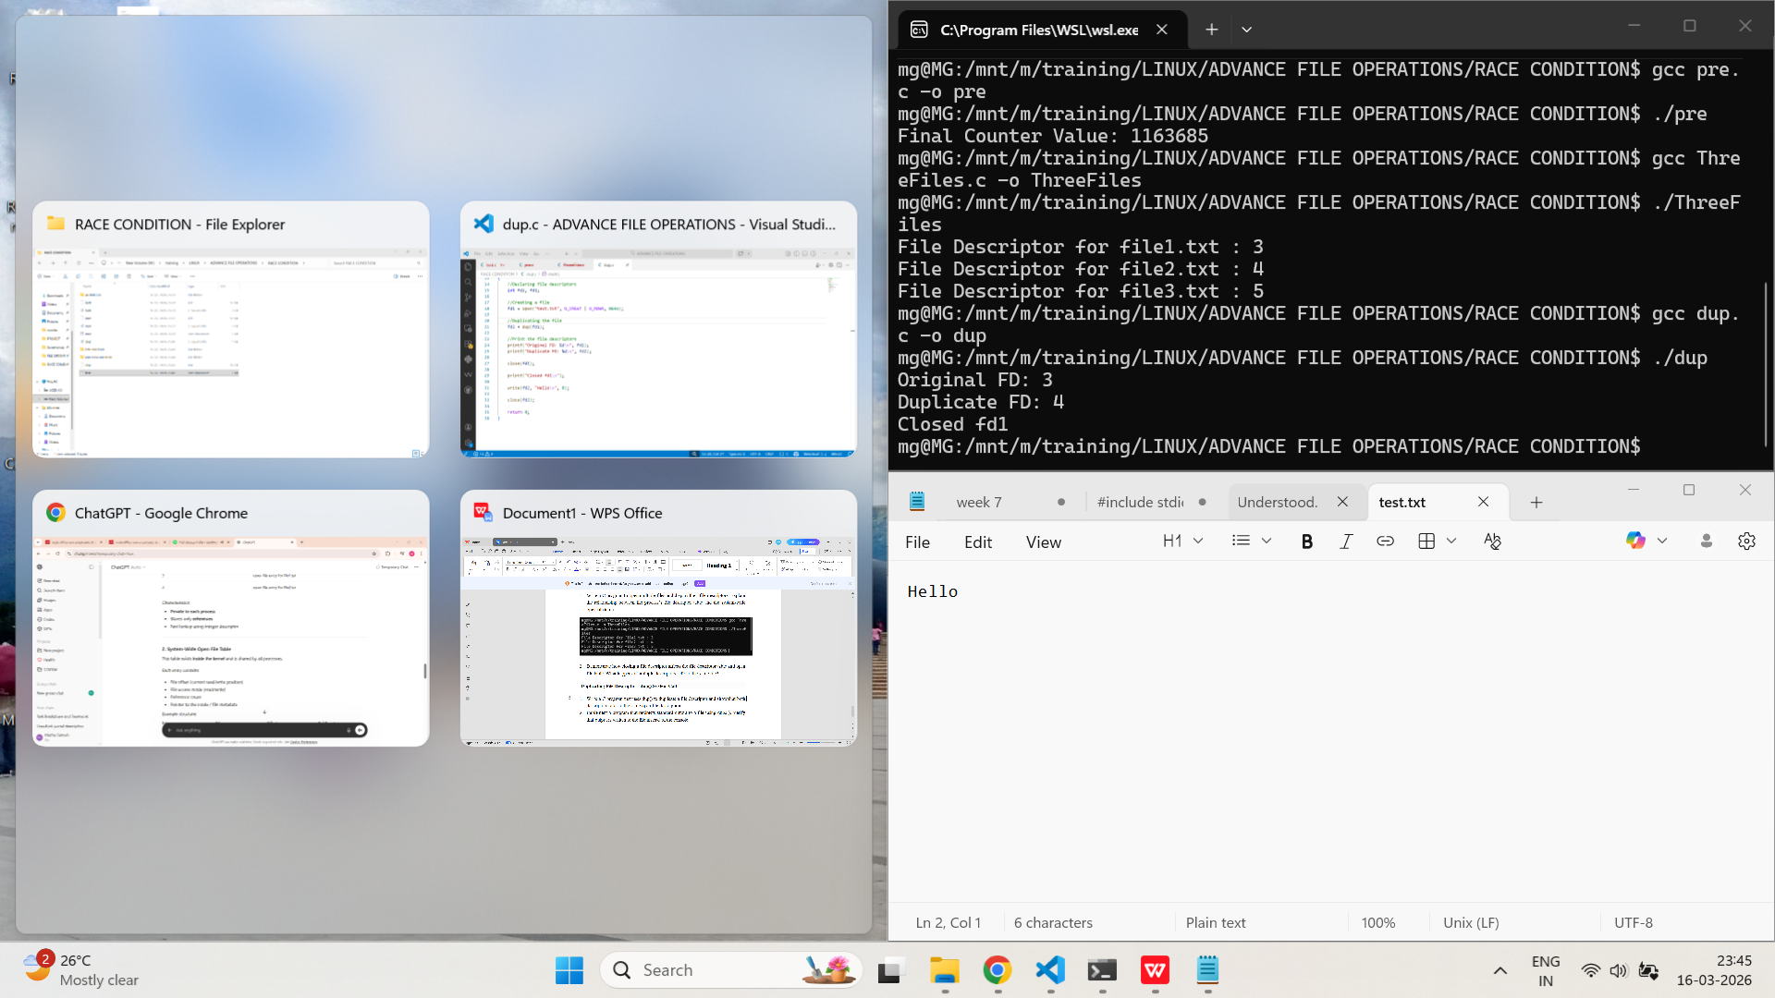
Duplicating File Descriptor - dup() System Call
- Write a C program that uses dup() to duplicate a file descriptor and show that both descriptors refer to the same open file description.
PROGRAM:
/*
Program to create a file and duplicate the file descriptor
Author : MUTHUGANESH S
Date : 05/02/2026
Filename : dup.c
*/

//header files
#include <stdio.h>
#include <fcntl.h>
#include <unistd.h>

int main()
{
int fd, fd_dup;

//Creating a file
fd = open("dup_example.txt", O_CREAT | O_RDWR | O_TRUNC, 0644);

if(fd < 0)
{
perror("open failed");
return 1;
}

//Duplicating the file
fd_dup = dup(fd);

printf("Original FD : %d\n", fd);
printf("Duplicated FD : %d\n", fd_dup);

write(fd, "Hello ", 6);
write(fd_dup, "World\n", 6);

close(fd);
close(fd_dup);

return 0;
}
OUTPUT:
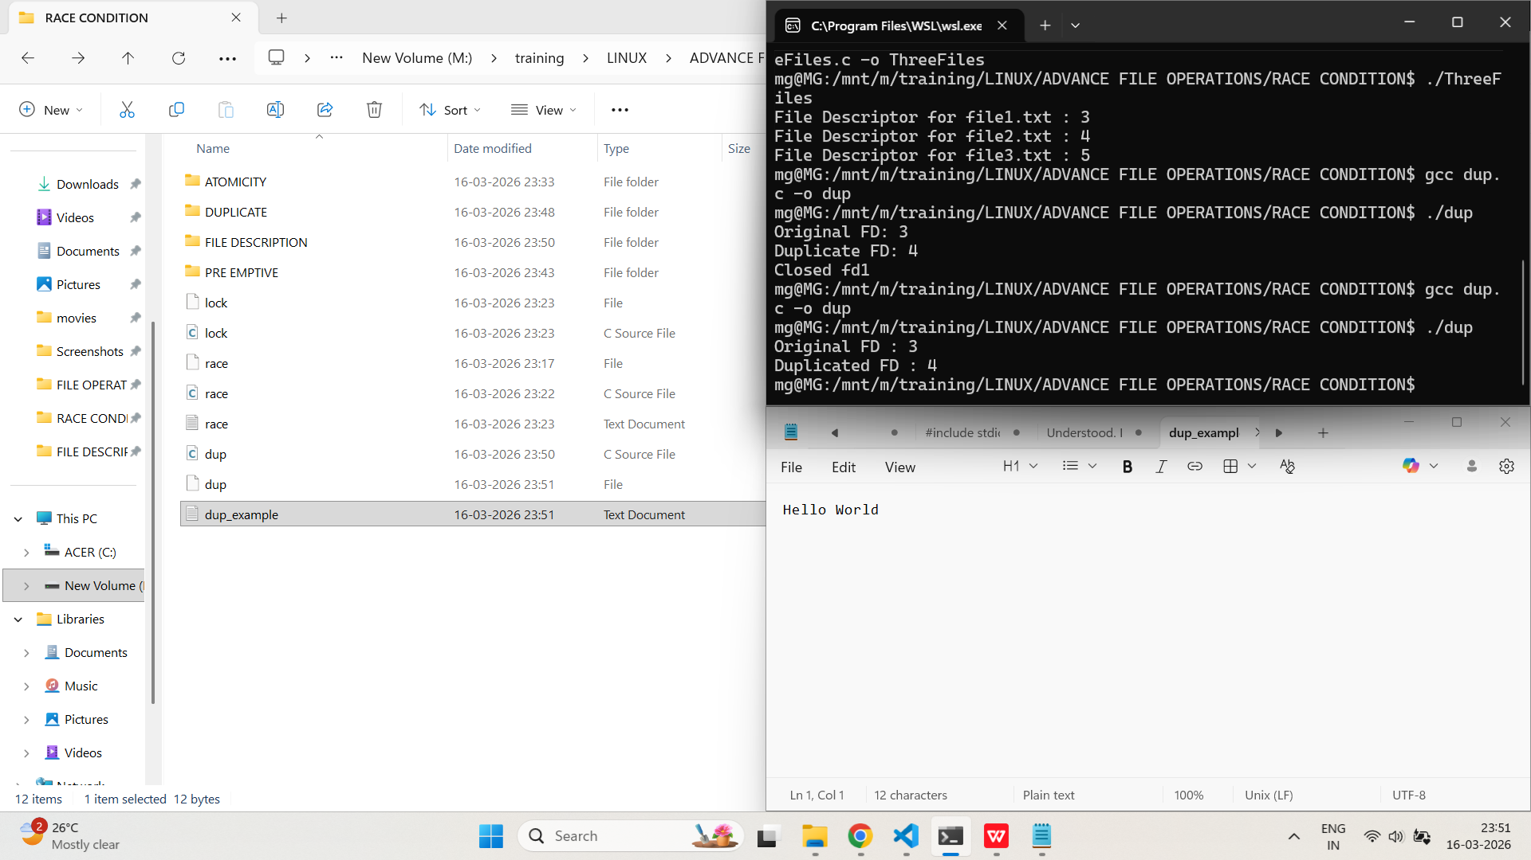

- Implement a program that redirects standard output to a file using dup2(). Verify that output is written to the file instead of the console.
PROGRAM:
/*
Program to create a file and redirect the standard output to the file
Author : MUTHUGANESH S
Date : 05/02/2026
Filename : red.c
*/

//Header files
#include <stdio.h>
#include <fcntl.h>
#include <unistd.h>
int main()
{
int fd;
//Creating a file
fd = open("output.txt", O_CREAT | O_WRONLY | O_TRUNC, 0644);
//Checking if the file is created
if(fd < 0)
{
perror("open failed");
return 1;
}
dup2(fd, STDOUT_FILENO);
printf("This line goes to the file\n");
printf("Standard output redirected\n");
close(fd);
return 0;
}
OUTPUT:
